To use this template, make a copy by selecting FILE / MAKE A COPY to make your own Google Docs file, or FILE / DOWNLOAD to create a word doc if you’d prefer to work offline.

## **Project “Unity RPG” 1.5-Page GDD**

*Brief Summary or Hook*

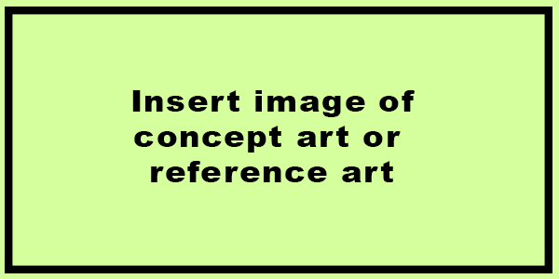

**Genre:** RPG  
**Target Audience:** OKATU, R 13

**Controls:** keyboard and mouse

**Thematic Setting:** fantasy, medival

**Tech Stack:** Unity

**Platform(s):** PC

**MVP Game Moment:** A to B level flow. Combat again 3 or 4 enemy types.

**Game Summary:**

**Core Player Experience:**

**Central Story Theme:**

**Design Pillar:**

**Remarkability:**

**Anticipated Steam Early Access Launch date:**

**Feature Development Priorities:**

**Reference Games:**